Section A: Vector Databases

A1. Explain in your own words what a vector database is and how it's different from a traditional database like MySQL or PostgreSQL
- A Vector Database stores data in the form of numerical vectors that represent the meaning or features of the data.
- It is mainly used to find information based on similarity rather than only exact matching.
- A traditional database stores data in tables, rows and columns and generally searches using conditions or keywords.
- In simple words, traditional DB finds an exact match, while vector DB finds similar or related information.
A2. Take any sentence of your choice. Describe what happens to it step by step from raw text to being stored in a vector database. Name each stage.
Example sentence: “Rohit Sharma was the captain of the Indian cricket team when we won the T20 World Cup in 2024.”
- Raw Text: The original sentence is taken as plain text. For example, the input is “Rohit Sharma was the captain of the Indian cricket team...”.
- Preprocessing and Tokenization: The sentence is cleaned if required and divided into smaller tokens such as “Rohit”, “Sharma”, “was”, “captain”, “Indian”, “cricket”, etc.
- Embedding Generation: Each token is processed by the embedding model and represented using numerical values. For example, an embedding might look like “Rohit” → [0.21, 0.45, 0.13, ...] and “Sharma” → [0.18, 0.39, 0.27, ...]. These are only example values; the actual numbers depend on the model.
- Vector Creation, Storage and Indexing: The model combines the information from the tokens and creates a vector representing the meaning of the complete sentence. This vector is then stored and indexed in the vector database along with the original text, so it can be searched later based on similarity.

A3. Why can't we just use a normal database index (like a B-tree) to search through embeddings? Explain the core difference between exact lookup and similarity search.
- A B-tree index is mainly used for data that can be arranged in a proper order, like numbers, dates, or words.
- Embeddings have many numerical dimensions, so comparing them in one fixed order is not practical.
- B-tree searches generally work with exact values or specific ranges, while vector databases look for data based on similarity or distance.
- Because of this, vector databases use indexing techniques such as HNSW to find similar vectors more efficiently.

You're given two vectors: A = [1, 2, 3] B = [2, 4, 6] Calculate the cosine similarity between A and B by hand, showing your steps. What does the result tell you about these two vectors?
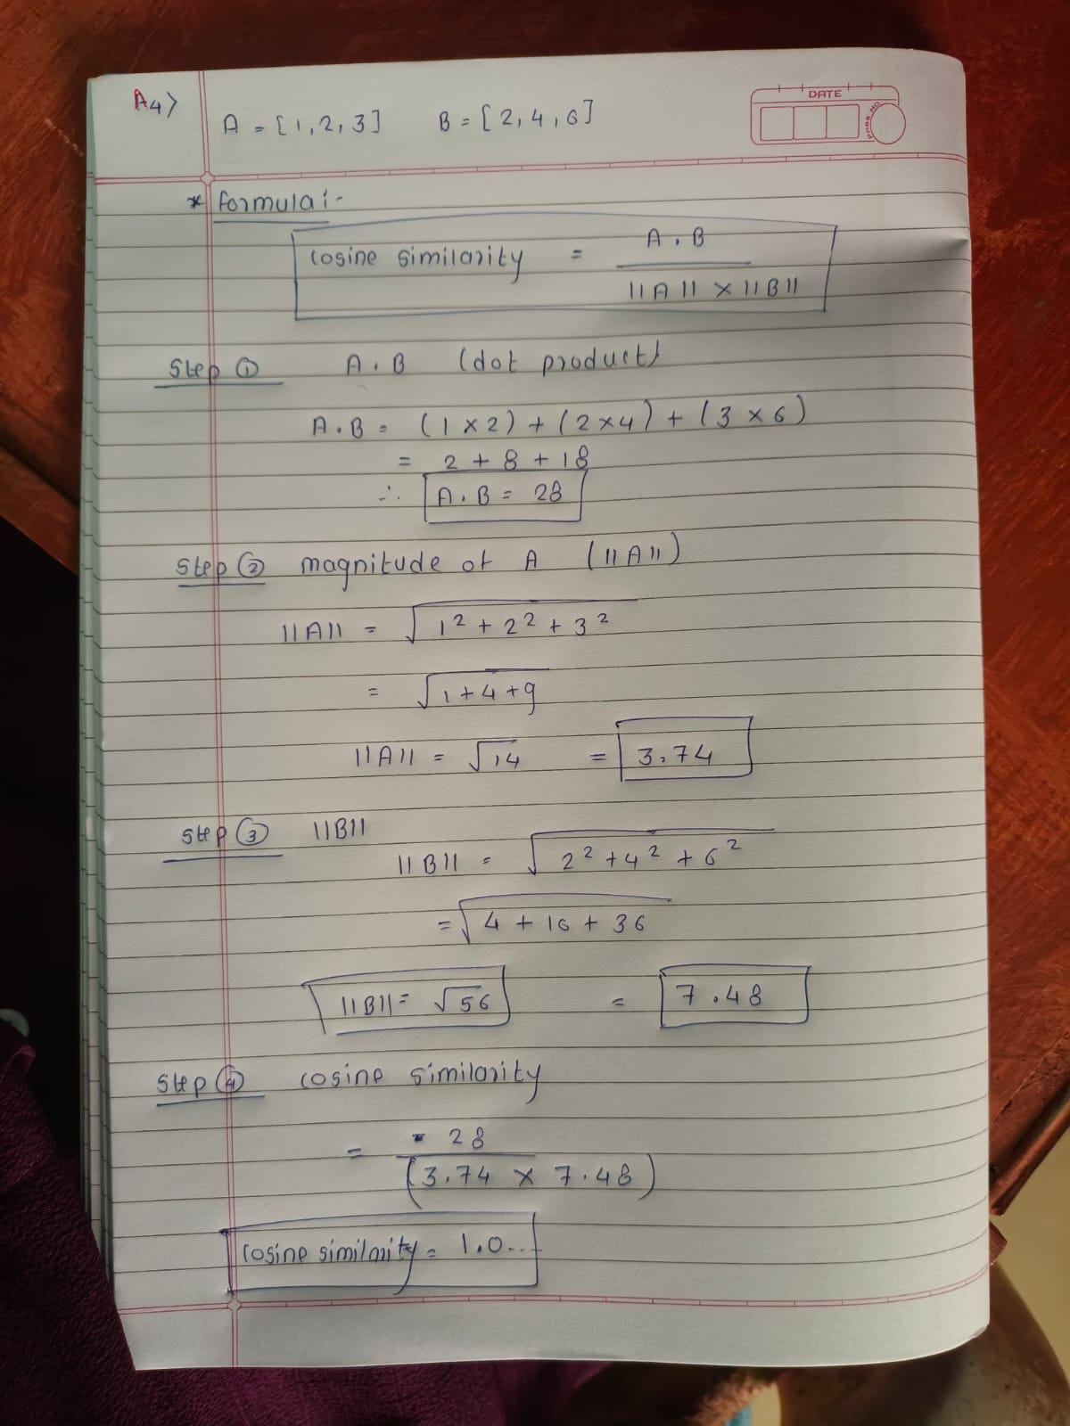
- The cosine similarity between A and B is 1.0.
- A similarity value of 1 means the two vectors point in exactly the same direction, it means both vector A and B are exact similar to each other .
- Here, B = 2A, so every value in B is exactly double the value in A.

A5. Explain why a vector database is essential for RAG specifically. What would break if you removed it from the pipeline?
- RAG uses a vector database to store and retrieve information that is relevant to the user’s query. For example, if the user asks about “resetting a password,” it can find related information stored in the database.

- It searches information based on meaning, even when the exact words are different. For example, “How can I change my password?” can match a document containing “steps to reset login credentials.”

- It makes retrieval from a large amount of data faster and more efficient, so RAG can provide the required information without checking every document one by one.

- If the vector database is removed, finding relevant information becomes slow and difficult for large datasets. As a result, the RAG system may not get the proper context needed to generate a useful answer.

